Assignment 4

Cailyn Cochran

CIS 310 – 01 | Due Date: 9/18/2017

**PART 1**

Use the database shown in Figure P3.1 to answer Problems 1–9.

1. For each table, identify the primary key and the foreign key(s). If a table does not have a foreign key, write *None*.

|  |  |  |
| --- | --- | --- |
| TABLE | PRIMARY KEY | FOREIGN KEY(S) |
| EMPLOYEE | EMP_CODE | STORE_CODE |
| STORE | STORE_CODE | REGION_CODE  EMP_CODE |
| REGION | REGION_CODE | NONE |

2. Do the tables exhibit entity integrity? Answer yes or no, and then explain your answer.

|  |  |  |
| --- | --- | --- |
| TABLE | ENTITY INTEGRITY | EXPLANATION |
| EMPLOYEE | YES | The EMPLOYEE table’s primary key is EMP_CODE. The EMPLOYEE primary key column has no null entries, and all entries unique. |
| STORE | YES | The EMPLOYEE table’s primary key is STORE_CODE. The STORE primary key column has no null entries, and all entries unique. |
| REGION | YES | The REGION table’s primary key is REGION_CODE. The REGION primary key column has no null entries, and all entries unique. |

|  |  |  |
| --- | --- | --- |
| TABLE | REFERENTIAL INTEGRITY | EXPLANATION |
| EMPLOYEE | YES | Table EMPLOYEE has one foreign key, STORE_CODE. The STORE_CODE entries in the EMPLOYEE table all match STORE_CODE entries in the STORE table. |
| STORE | YES | Table STORE has two foreign keys, EMP_CODE and REGION_CODE. The EMP_CODE and REGION_CODE entries in the STORE table all match STORE_CODE entries in the STORE table. |
| REGION | N/A | Table does not have a foreign key |

3. Do the tables exhibit referential integrity? Answer yes or no, and then explain

your answer. Write *NA* (Not Applicable) if the table does not have a foreign key.

**PART 2**

Find the natural join of the STUDENT table and the PROFESSOR table on page 108. You must show all the intermediate steps and the final result to get credit.

**STUDENT TABLE PROFESSOR TABLE**

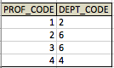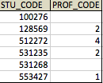

**STEP 1: PRODUCT**

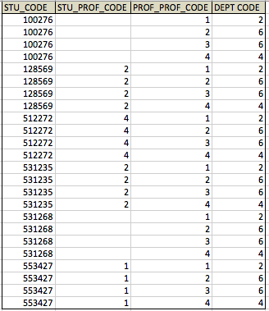

**STEP 2: SELECT**

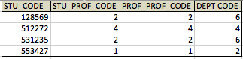

**STEP 3: PROJECT**

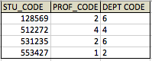

Submit the assignment before the due date and time on Blackboard. Bring a printed copy to class. No late submission allowed.